Random Advice for Preparing a Talk Nancy Reid, October 2016

The look of your slides

- Most people use the beamer class in LateX, see, for example https://www.sharelatex.com/learn/Beamer.
  - Powerpoint can be easier if you have a lot of pictures, but the mathematics often looks a bit weird. I use LateXiT to insert mathematics if I’m using PP: https://www.macupdate.com/app/mac/17889/latexit

- Get rid of the beamer junk in the bottom corner of your slide with \beamertemplatenavigationsymbolsempty in your preamble.

- Use a simple slide theme. Many versions use up a lot of screen space with outline text and this is rarely helpful. https://www.hartwork.org/beamer-theme-matrix/
  - On the left an (imho) awful example (Berkeley theme): -- chartjunk at the bottom, ugly box bullets, wasted screen space. On the right a much cleaner look (Singapore theme).
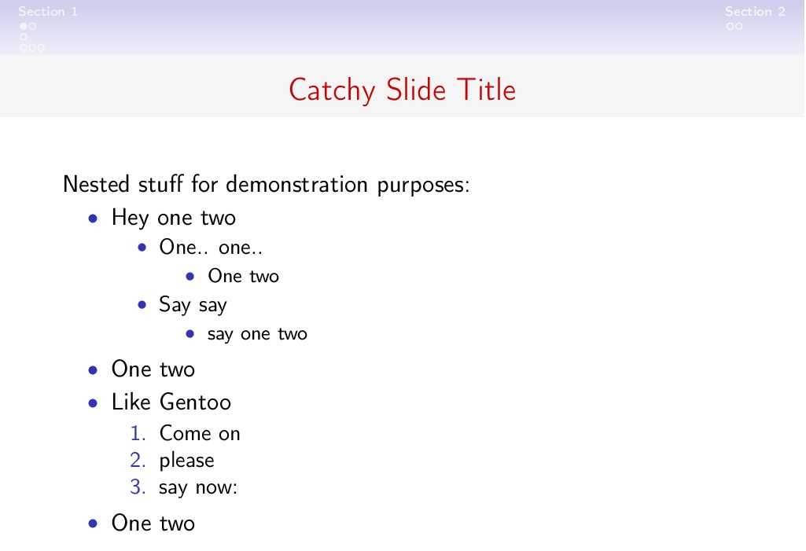
- You can find nice themes by poking around the internet; for example Karl Broman has made available a design with an especially clean look: see https://kbroman.wordpress.com/2013/10/07/better-looking-latexbeamer-slides/
- \setlength{\leftmargini}{5pt} gives you a smaller left margin, often useful if you have a lot of bullet lists
- \documentclass[t]{beamer} starts text at the top of the slide; leaving this out centers the text vertically. I think it looks better at the top.

- Use colours, not bold or italics, to highlight words or phrases. But use them sparingly – three colours should be enough for any talk. Don’t use \green – create a darker green if green is your favourite colour

The presentation

- Plan on one slide per minute of allotted time. Do you really need an outline slide? Possibly, for a one-hour presentation, but very very rarely for half an hour or less.

- Beware the laser pointer. They often don’t work, and when they do they often jump around. You can highlight points in many creative ways in beamer
  - the easiest is to put \pause after a block of text.
    - On the first line of your tex file: \documentclass[handout]{beamer} will put all the text of a slide at once
    - \documentclass[]{beamer} will dynamically uncover your text
  - You can use the laptop mouse or trackpad
  - Depending on the room, you can walk to the screen

- Get to know the microphone. Get comfortable using a portable mike, or make yourself stand at the podium mike (and then don’t turn your head to look at your slides). If people ask you to use the mike, use it. Don’t say “I’m sure everyone can hear me”; if a mike is available, it’s probably because that is not true.

Practice, practice, practice

- Go to lots of talks. If you get bored or lost, re-design the speaker’s slides. If you really like the speaker’s slides, tell her that. Most people are very happy to share their slide tips with others.

- Read Brad Efron’s “Thirteen Rules” in the Past, Present, and Future of Statistical Science, edited by X. Lin et al. and published by CRC Press. It’s fun, short and informative.

